DESIGN & ANALYSIS OF ALGORITHMS (10CS43)

UNIT-VII

COPING WITH LIMITATIONS OF ALGORITHMIC POWER
Backtracking:
      - n - Queens Problem
      - Subset –Sum Problem
Branch-and-Bound:
      - Assignment Problem
Approximation Algorithms for NP-Hard Problems:
- Traveling Salesperson Problem

- BACKTRACKING

The principal idea in Backtracking is to construct solutions one component at a time and evaluate partially constructed candidates as follows. If a partially constructed solution can be developed further without violating the problem’s constraints, it is done by taking the first remaining legitimate option for the next component. If there is no legitimate option for the next component, no alternatives for any remaining component need to be considered. In this case, the algorithm backtracks to replace the last component of the partially constructed solution with its next option.
It is convenient to implement this kind of processing by constructing a tree of choices being made, called the state-space tree. Its root represents an initial state before the search for a solution begins. The nodes of the first level in the tree represent the choices made for the first component of a solution, the nodes of the second level represent the choices for the second component, and so on. A node in a state-space tree is said to be promising if it corresponds to a partially constructed solution that may still lead to a complete solution; otherwise, it is called nonpromising. Leaves represent either nonpromising dead ends or complete solutions found by the algorithm. A statespace tree for a backtracking algorithm is constructed in the manner of depthfirst search. If the current node is promising, its child is generated by adding the first remaining legitimate option for the next component of a solution, and the processing moves to this child. If the current node turns out to be nonpromising, the algorithm backtracks to the node’s parent to consider the next possible option for its last component; if there is no such option, it backtracks one more level up the tree, and so on. Finally, if the algorithm reaches a complete solution to the problem, it either stops or continues searching for other possible solutions.

a. n-Queens Problem

The problem is to place n queens on an n × n chessboard so that no two queens attack each other by being in the same row or in the same column or on the same diagonal. For n = 1, n = 2 and n = 3 there is no solution. So let us consider the four-queen problem and solve it by the backtracking technique. Since each of the four queens has to be placed in its own row, all we need to do is to assign a column for each queen on the board presented in Figure 12.1.
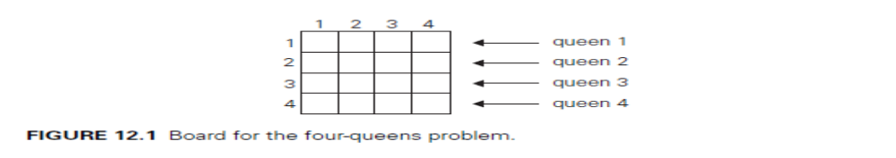
We start with the empty board and then place queen 1 in the first possible position of its row, which is in column 1 of row 1. Then we place queen 2, after trying unsuccessfully columns 1 and 2, in the first acceptable position for it, which is square (2, 3), the square in row 2 and column 3. This proves to be a dead end because there is no acceptable position for queen 3. So, the algorithm backtracks and puts queen 2 in the next possible position at (2, 4). Then queen 3 is placed at (3, 2), which proves to be another dead end. The algorithm then backtracks all the way to queen 1 and moves it to (1, 2). Queen 2 then goes to (2, 4), queen 3 to (3, 1), and queen 4 to (4, 3), which is a solution to the problem. The state-space tree of this search is shown in Figure 12.2.
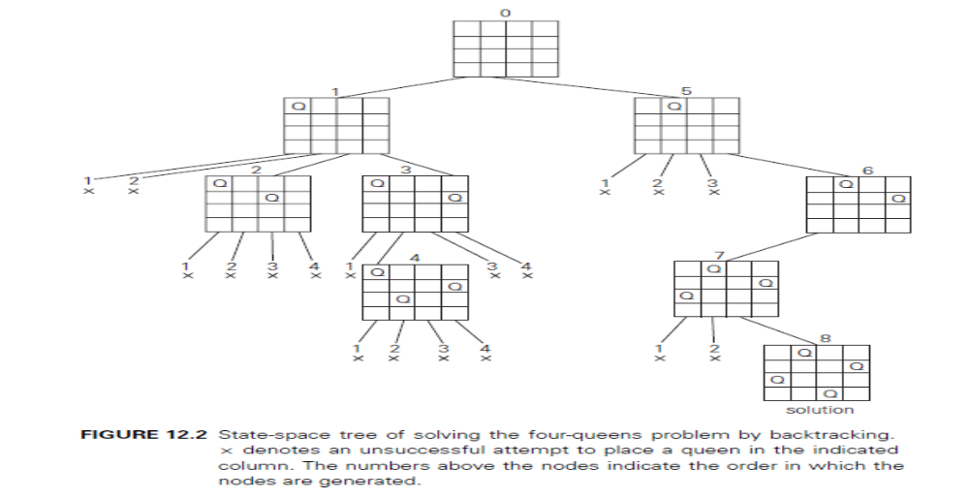
If other solutions need to be found the algorithm can simply resume its operations at the leaf at which it stopped. State-space tree of solving the four-queen problem by backtracking. × denotes an unsuccessful attempt to place a queen in the indicated column. The numbers above the nodes indicate the order in which the nodes are generated.

b. Subset-Sum Problem
Consider the example for subset-sum problem: to find a subset of a given set A = {a1, . . . , an} of n positive integers whose sum is equal to a given positive integer d. For example, for A = {1, 2, 5, 6, 8} and d = 9, there are two solutions: {1, 2, 6} and {1, 8}. It is convenient to sort the set’s elements in increasing order. So, we will assume that a1< a2 < . . . < an.
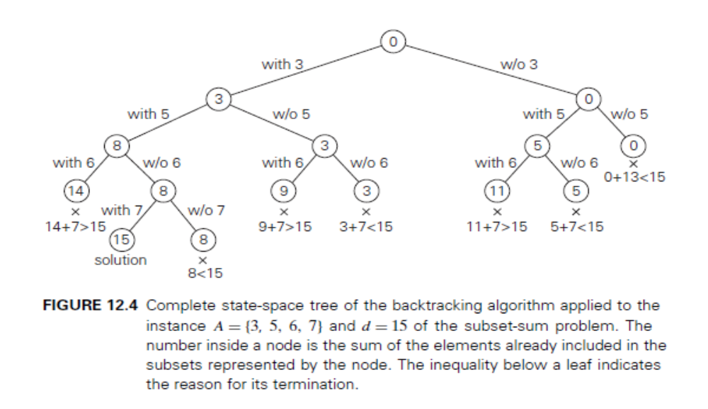
The state-space tree can be constructed as a binary tree like that in Figure 12.4 for the instance A = {3, 5, 6, 7} and d = 15. The root of the tree represents the starting point, with no decisions about the given elements made as yet. Its left and right children represent, respectively, inclusion and exclusion of a1 in a set being sought.
Similarly, going to the left from a node of the first level corresponds to inclusion
of a2 while going to the right corresponds to its exclusion, and so on. Thus, a path from the root to a node on the i^{th} level of the tree indicates which of the first i numbers have been included in the subsets represented by that node. We record the value of s, the sum of these numbers, in the node. If s is equal to d, we have a solution to the problem. We can either report this result and stop or, if all the solutions need to be found, continue by backtracking to the node’s parent. If s is not equal to d, we can terminate the node as nonpromising if either of the following two inequalities holds:
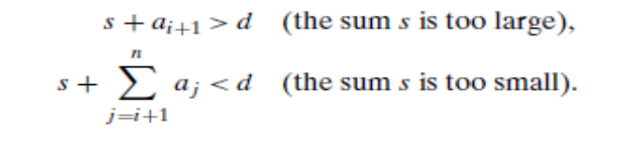
II. Branch-and-Bound
The branch-and-bound requires two additional items:

- a way to provide, for every node of a state-space tree, a bound on the best value of the objective function on any solution that can be obtained by adding further components to the partially constructed solution represented by the node

- the value of the best solution seen so far

If this information is available, we can compare a node’s bound value with the value of the best solution seen so far. If the bound value is not better than the value of the best solution seen so far—i.e., not smaller for a minimization problem and not larger for a maximization problem—the node is nonpromising and can be terminated. Indeed, no solution obtained from it can yield a better solution than the one already available. This is the principal idea of the branch-and-bound technique.
In general, a search path at the current node is terminated in a state-space tree of a branch-and-bound algorithm for any one of the following three reasons:

- The value of the node’s bound is not better than the value of the best solution seen so far.

- The node represents no feasible solutions because the constraints of the problem are already violated.

- The subset of feasible solutions represented by the node consists of a single point—in this case, we compare the value of the objective function for this feasible solution with that of the best solution seen so far and update the latter with the former if the new solution is better.

a. Assignment Problem
Let us illustrate the branch-and-bound approach by applying it to the problem of assigning n people to n jobs so that the total cost of the assignment is as small as possible. The problem is the instance of the assignment problem is specified by an n × n cost matrix C so that we can state the problem as follows: select one element in each row of the matrix so that no two selected elements are in the same column and their sum is the smallest possible.
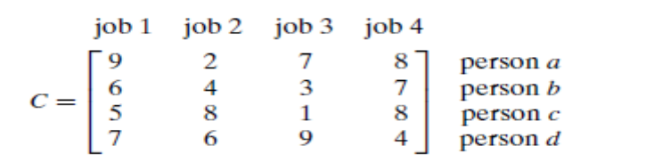
A lower bound can be found by the summing the smallest elements in each of the matrix’s rows. For the instance here, this sum is 2 + 3+ 1+ 4 = 10. It is important to stress that this is not the cost of any legitimate selection (3 and 1 came from the same column of the matrix);it is just a lower bound on the cost of any legitimate selection. We can and will apply the same to partially constructed solutions. For example, for any legitimate selection that selects 9 from the first row, the lower bound will be
9 + 3 + 1+ 4 = 17.
State-space tree deals with the order in which the tree nodes will be generated. It generate all the children of the most promising node among nonterminated leaves in the current tree. (Nonterminated, i.e., still promising, leaves are also called live.) How can we tell which of the nodes is most promising? We can do this by comparing the lower bounds of the live nodes. It is sensible to consider a node with the best bound as most promising, although this does not, of course, stop the possibility that an optimal solution will ultimately belong to a different branch of the state-space tree. This variation of the strategy is called the best-first branch-and-bound.
So, returning to the instance of the assignment problem given earlier, we start with the root that corresponds to no elements selected from the cost matrix. As we already discussed, the lower-bound value for the root, denoted lb, is 10. The nodes on the first level of the tree correspond to selections of an element in the first row of the matrix, i.e., a job for person a (Figure 12.5).
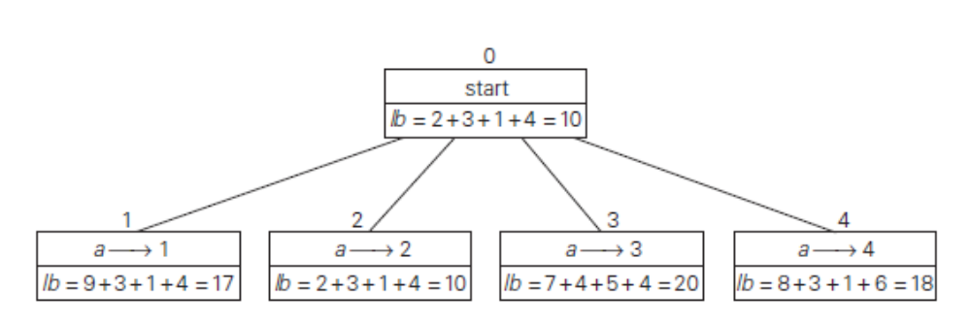
So we have four live leaves—nodes 1 through 4—that may contain an optimal solution. The most promising of them is node 2 because it has the smallest lowerbound value. Following our best-first search strategy, we branch out from that node first by considering the three different ways of selecting an element from the second row and not in the second column—the three different jobs that can be assigned to person b (Figure 12.6).
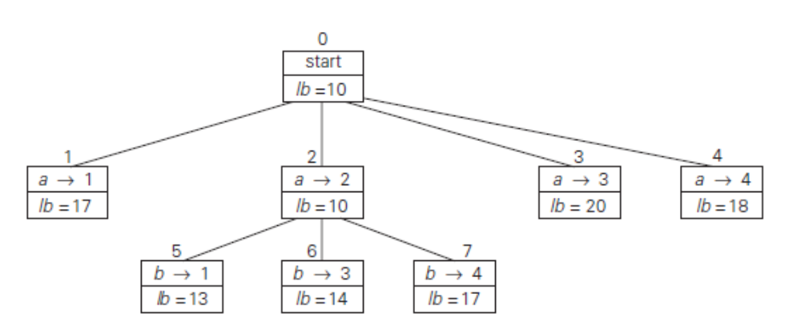
Of the six live leaves—nodes 1, 3, 4, 5, 6, and 7—that may contain an optimal solution, we again choose the one with the smallest lower bound, node 5. First, we consider selecting the third column’s element from c’s row (i.e., assigning person c to job 3); this leaves us with no choice but to select the element from the fourth column of d’s row (assigning person d to job 4). This yields leaf 8 (Figure 12.7), which corresponds to the feasible solution {a→2, b→1, →3, d →4} with the total cost of 13. Its sibling, node 9, corresponds to the feasible solution {a→2,
b→1, c→4, d →3} with the total cost of 25. Since its cost is larger than the cost of the solution represented by leaf 8, node 9 is simply terminated. (Of course, if its cost were smaller than 13, we would have to replace the information about the best solution seen so far with the data provided by this node.)
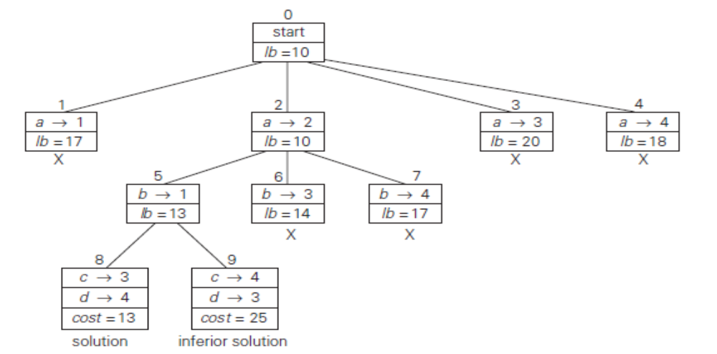
Now, as we inspect each of the live leaves of the last state-space tree—nodes 1, 3, 4, 6, and 7 in Figure 12.7—we discover that their lower-bound values are not smaller than 13, the value of the best selection seen so far (leaf 8). Hence, we terminate all of them and recognize the solution represented by leaf 8 as the optimal solution to the problem.

III. Approximation Algorithms for the Traveling Salesman Problem
i)Greedy Algorithms for the TSP The simplest approximation algorithms for the traveling salesman problem are based on the greedy technique. Two such algorithms are.

a. Nearest-neighbor algorithm
The following well-known greedy algorithm is based on the nearest-neighbor heuristic: always go next to the nearest unvisited city.
Step 1 Choose an arbitrary city as the start.
Step 2 Repeat the following operation until all the cities have been visited: go to the unvisited
city nearest the one visited last (ties can be broken arbitrarily).
Step 3 Return to the starting city.

EXAMPLE For the instance represented by the graph in Figure 12.10, with a as the starting vertex, the nearest-neighbor algorithm yields the tour sª: a − b − c − d − a of length 10.
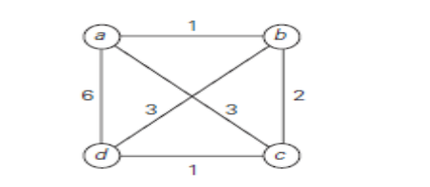
The optimal solution, as can be easily checked by exhaustive search, is the tour s∗: a − b − d − c − a of length 8. Thus, the accuracy ratio of this approximation is
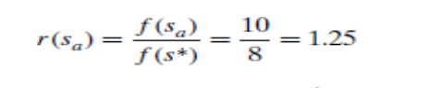
(i.e., tour sa is 25% longer than the optimal tour s∗).

b. Multifragment-heuristic algorithm
Another natural greedy algorithm for the traveling salesman problem considers it as the problem of finding a minimum-weight collection of edges in a given complete weighted graph so that all the vertices have degree 2. An application of the greedy technique to this problem leads to the following algorithm.
Step 1 Sort the edges in increasing order of their weights. (Ties can be broken arbitrarily.)
Initialize the set of tour edges to be constructed to the empty set.
Step 2 Repeat this step n times, where n is the number of cities in the instance being solved:
add the next edge on the sorted edge list to the set of tour edges, provided this
addition does not create a vertex of degree 3 or a cycle of length less than n; otherwise,
skip the edge.
Step 3 Return the set of tour edges.
ii)Minimum-Spanning-Tree–Based Algorithms There are approximation algorithms for the traveling salesman problem that exploit a connection between Hamiltonian circuits and spanning trees of the same graph. Since removing an edge from a Hamiltonian circuit yields a spanning tree, we can expect that the structure of a minimum spanning tree provides a good basis for constructing a shortest tour approximation. Here is an algorithm that implements this idea in a rather straightforward fashion.
a. Twice-around-the-tree algorithm
Step 1 Construct a minimum spanning tree of the graph corresponding to a given instance of the traveling salesman problem.
Step 2 Starting at an arbitrary vertex, perform a walk are und the minimum spanning tree recording all the vertices passed by. (This can be done by a DFS traversal.)
Step 3 Scan the vertex list obtained in Step 2 and eliminate from it all repeated occurrences of the same vertex except the starting one at the end of the list. (This step is equivalent to making shortcuts in the walk.) The vertices remaining on the list will form a Hamiltonian circuit, which is the output of the algorithm.

EXAMPLE Let us apply this algorithm to the graph in Figure 12.11a. The minimum spanning tree of this graph is made up of edges (a, b), (b, c), (b, d), and (d, e) (Figure 12.11b). A twice-around-the-tree walk that starts and ends at a.
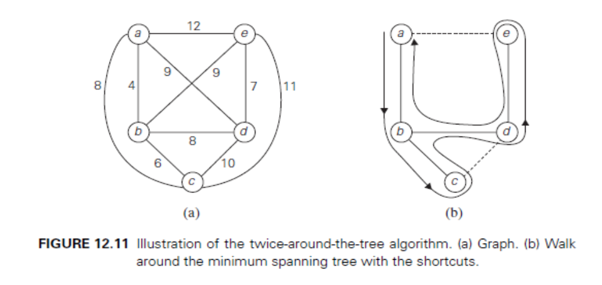
FIGURE Illustration of the twice-around-the-tree algorithm. (a) Graph. (b) Walk around the minimum spanning tree with the shortcuts. a, b, c, b, d, e, d, b, a. Eliminating the second b (a shortcut from c to d), the second d, and the third b (a shortcut from e to a) yields the Hamiltonian circuit a, b, c, d, e, a of length 39. The tour obtained in example is not optimal.

